**ASSIGNMENT 2 PROBLEMS ON CONTROL STATEMENT**

Number series

1.Write a Program to print series 0 2 6 12 20 30 42 ...N.

PROGRAM

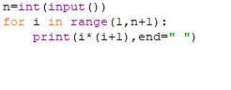

OUTPUT



2. Write a Program to print series 0,2,8,14,24,34 ...N.

PROGRAM

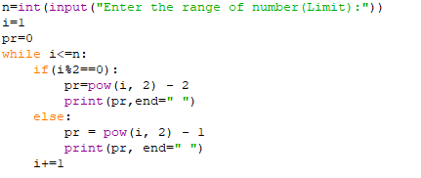

OUTPUT



3. Write a program to print Arithmetic series 1 4 7 10...

PROGRAM

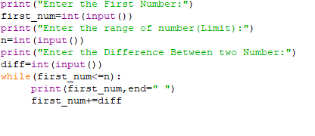

OUTPUT

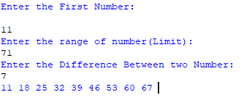

4. Write a Program to Find the sum of series 1³+2³+3³+4³.....+N³.

PROGRAM

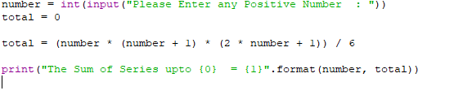

OUTPUT

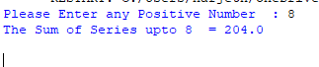

5. Write a Program to Find the sum of series 2+4+6+8.....+N.

PROGRAM

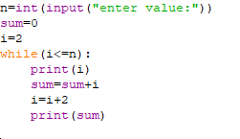

OUTPUT

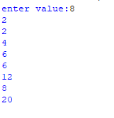

6.Write a Program to Find the sum of series 1+11+111+1111.....+N.

PROGRAM

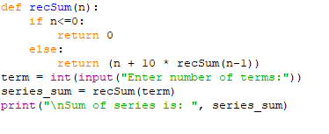

OUTPUT

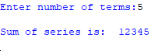

7.Write a program to find the sum of series 1/2!+2/3!+3/5!+4/6!+.....N/(N+1)!

PROGRAM

#Series 1/2!+2/3!+3/4!.....N/(N+1)!

s=0

f=1

n=int(input("Enter the number:"))

for i in range(1,n+1):

f=(f+1)*i

s=s+(i/f)

print(s)

OUTPUT

Enter the number:5

1.0328809767012013

8.Write a Program to print the Fibonacci series

PROGRAM

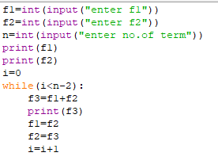

OUTPUT

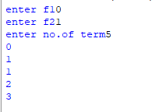

9.Write a program to find the sum of series 1+3+5+7..+N.

PROGRAM

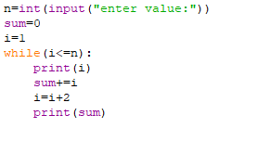

OUTPUT

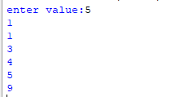

10.Write a program to find the sum of series 1+2+3..+N.

PROGRAM

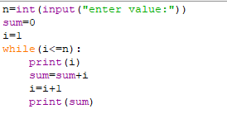

OUTPUT

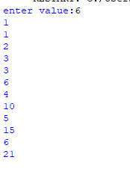

11.Write a Program to find the sum of series 1!+2!+3!...+n!

PROGRAM

12.Write a Program to Find the sum of series 9+99+999+9999.....+N.

PROGRAM

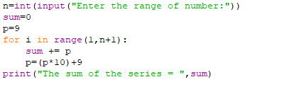

OUTPUT



Number Pattern

1. Python program to print the following simple number pattern using a [for loop](https://pynative.com/python-for-loop/).

1

2 2

3 3 3

4 4 4 4

5 5 5 5 5

PROGRAM

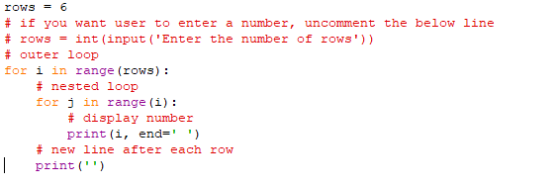

OUTPUT

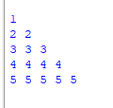

**2. Pyramid pattern of numbers**

Let’s see how to print the following half pyramid pattern of numbers

1

1 2

1 2 3

1 2 3 4

1 2 3 4 5

PROGRAM

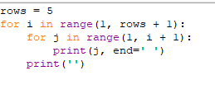

OUTPUT

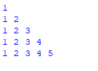

**3. Inverted pyramid pattern of numbers**

An inverted pyramid is a downward pattern where numbers get reduced in each iteration, and on the last row, it shows only one number. Use reverse for loop to print this pattern.

**Pattern**

1 1 1 1 1

2 2 2 2

3 3 3

4 4

5

PROGRAM

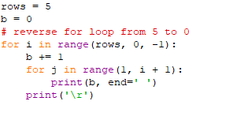

OUTPUT

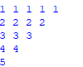

**4. Inverted Pyramid pattern with the same digit**

**Pattern**: –

5 5 5 5 5

5 5 5 5

5 5 5

5 5

5

PROGRAM

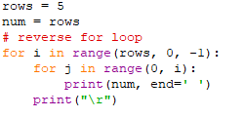

OUTPUT

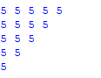

5. **Alternate numbers pattern using while loop**

Let’s see how to use the [while loop](https://pynative.com/python-while-loop/) to print the number pattern.

**Pattern**: –

1

3 3

5 5 5

7 7 7 7

9 9 9 9 9

PROGRAM

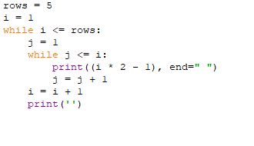

OUTPUT

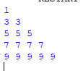

**6. Reverse Pyramid of Numbers**

**Pattern 2**: –

1

2 1

3 2 1

4 3 2 1

5 4 3 2 1

PROGRAM

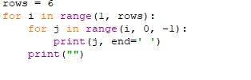

OUTPUT

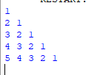

**Pyramid Patterns**

**1. Simple half pyramid pattern**: –

*

* *

* * *

* * * *

* * * * *

PROGRAM

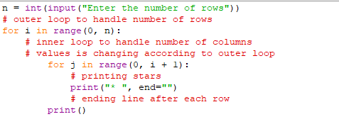

OUTPUT

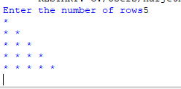

### 2. Downward half-Pyramid Pattern of Star

Pattern: –

* * * * *

* * * *

* * *

* *

*

PROGRAM

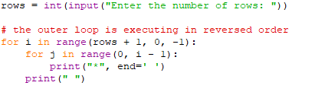

OUTPUT

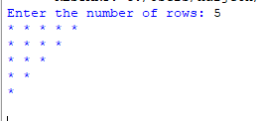

### 3. Downward full Pyramid Pattern of star

Let’s see how to print reversed pyramid pattern in Python.

Pattern: –

* * * * * *

* * * * *

* * * *

* * *

* *

*

PROGRAM

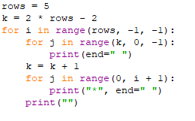

OUTPUT

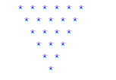

4. Right down mirror star Pattern

Pattern: –

*****

****

***

**

*

PROGRAM

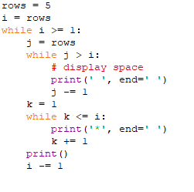

OUTPUT

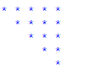

### 5. Equilateral triangle pattern of star

Pattern: –

*

* *

* * *

* * * *

* * * * *

* * * * * *

PROGRAM

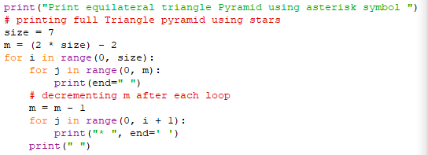

OUTPUT

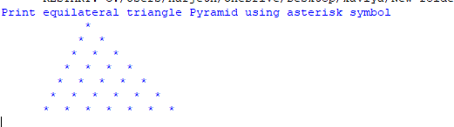

### 6. Right start pattern of star

Pattern: –

*

* *

* * *

* * * *

* * * * *

* * * *

* * *

* *

*

PROGRAM

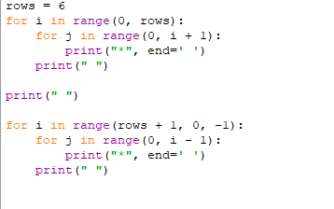

OUTPUT

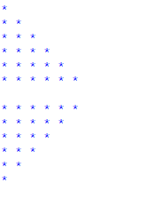

PROBLEMS

1. Convert decimal to binary number

PROGRAM

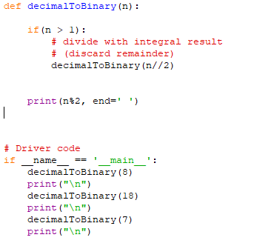

OUTPUT

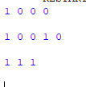

1. Given number is Armstrong number

PROGRAM

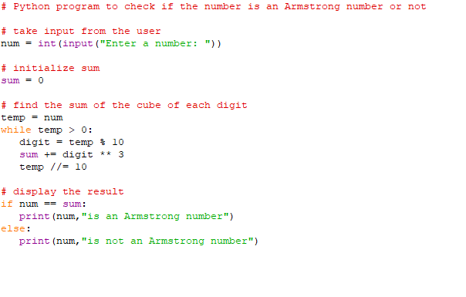

OUTPUT



1. Reversing a Number

PROGRAM

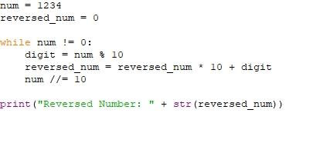

OUTPUT



1. Print all the leap year from 1900 - 2000

PROGRAM  
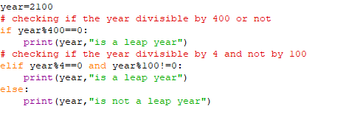

OUTPUT

